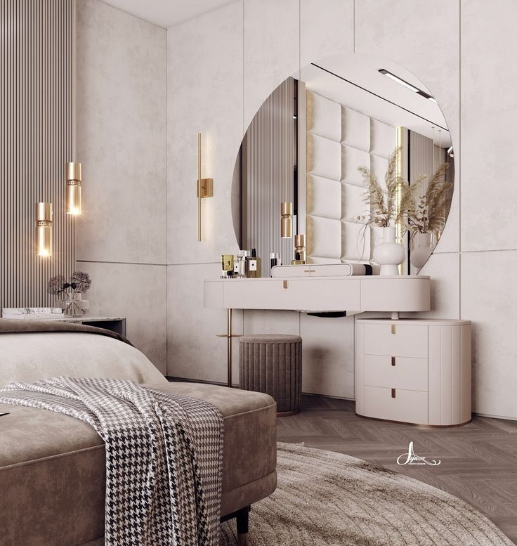***Bring Elegance & Warmth to Your Bedroom with the Perfect Mirror***

Your bedroom is your personal sanctuary — a space where comfort meets style and self-expression. Our carefully curated collection of **Bedroom Mirrors** is designed to enhance that serene environment by adding a touch of grace, depth, and practical functionality. Whether you're getting ready for the day or unwinding at night, the right mirror completes the bedroom experience.

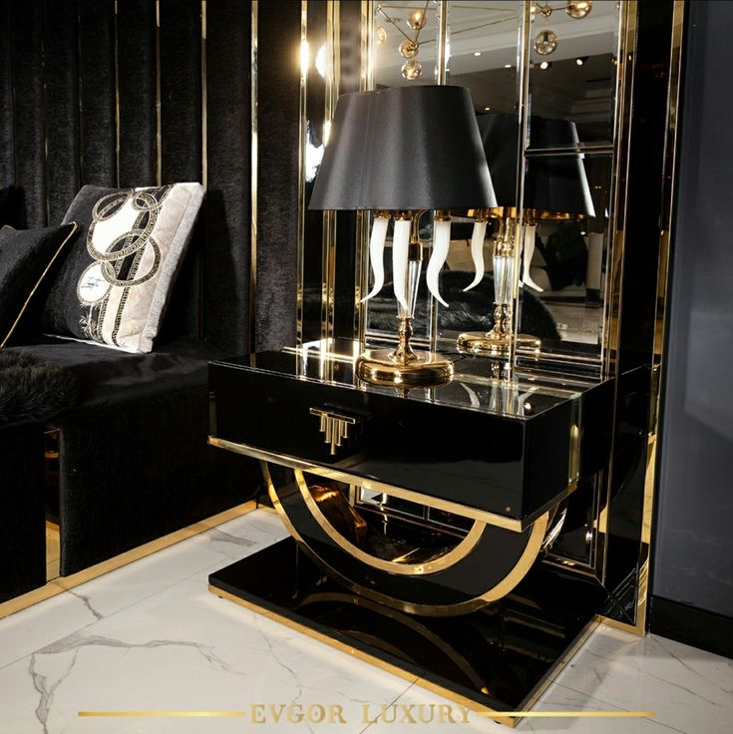Choose from a wide range of designs: full-length standing mirrors for outfit checks, wall-mounted round mirrors that blend seamlessly with modern interiors. Each mirror is crafted with smooth reflective surfaces and elegant frames, available in wood, metal, or soft matte finishes — ensuring they complement your bedroom’s color palette and furniture.

Our Bedroom Mirrors don’t just reflect your image — they reflect your lifestyle. With options that create the illusion of space and brighten up your room by bouncing natural light, these mirrors offer a perfect blend of style and substance. Built with high-quality materials and timeless designs, they're made to be both beautiful and lasting.

Let your bedroom mirror tell a story of style, comfort, and sophistication — every single day.